Kingdom of Saudi Arabia
Ministry of Education
King Faisal University
College of Computer Sciences & Information Technology

Artificial Intelligence
Parking Challenges Faced by Students and the Public

A project submitted
in partial fulfillment of the requirements for the degree of
Bachelor of Science in Computer Science

By
Section 82
Student’s Name | Student’s ID
Anfal Ahmad | 222430500
Zainab Abdulkarim | 222405495
Atekah Aljafar | 222427138
Maryam Alshabib | 223050271

Submitted to
Ms. Muneerah Alhajri
May, 2025
Contents
1. Problem Definition 3
Project Logbook 1.1: List the problems you have come up with. 3
Discussion for each identified problem 3
Project Logbook 1.2: Narrow down Problems 3
Discussion for each selected problem. 3
Project Logbook 1.3: Selected problem to tackle 4
Project Logbook 1.4: Problem Statement 4
2. Understanding Project Stakeholders (Users) 4
Project Logbook 2.1: User Identification 4
User Description 5
Project Logbook 2.3: User experience 5
3. Solution Identification 9
Project Logbook 3.1: Selection and Justification of Solution 9
Discussion for each identified solution 9
Project Logbook 3.2: Prioritizing Idea/Solution 10
Project Logbook 3.3: Solution Description 10
What is our solution? 10
How we will implement the solution: 10
4. Solution Design 11
Project Logbook 4.1: System Flow 11
System flow Diagram 12
5. Data Requirements 13
Project Logbook 5.1: Data Description 13
Project Logbook 5.2: Data Collection and Ethical issues 13
6. Protype Development 14
Project Logbook 6.1: Tools used for Project Prototyping 14
Project Logbook 6.2: Results Discussion 14
Project Logbook 6.3: Testing Prototype 14
Project Logbook 6.4: Testing Feedback 15
Project Logbook 6.5: Recommendations and Future Improvement 15
Project Logbook 6.6: Screen shot of Prototype 16
7. Student Reflection 19
Project Logbook 7.1: Learning Reflection 19
References 20

Parking Challenges Faced by Students and the Public.

1. Problem Definition

Project Logbook 1.1: List the problems you have come up with.
- Enhancing In-Store Product Location with AI for a Smarter and Sustainable Shopping Experience.
- Managing Damaged Machines in Educational Labs.
- Parking Challenges Faced by Students and the Public.

Discussion for each identified problem
- Enhancing In-Store Product Location with AI for a Smarter and Sustainable Shopping Experience :
Despite technological advances, many grocery stores still struggle with inefficiencies related to product location and customer navigation. Shoppers often face difficulties in locating specific items, especially in large or unfamiliar stores, leading to frustration and wasted time. This issue is particularly challenging during peak hours, where congestion and disorganization further degrade the shopping experience. Moreover, frequent layout changes, lack of real-time updates, and insufficient in-store assistance contribute to shopper dissatisfaction. These operational inefficiencies not only reduce consumer convenience but also hinder stores’ efforts toward sustainable resource management, as prolonged shopping time may lead to increased energy usage and workforce strain.
- Managing Damaged Machines in Educational Labs :
One of the most common problems observed in educational laboratories is the delay in detecting and managing faulty equipment. This is often due to the lack of automated monitoring systems and reliance on manual reports from students or lab supervisors. As a result, equipment may remain idle for long periods before it is noticed, interrupting learning activities and experiments. This delay can also lead to further equipment deterioration, increasing maintenance costs.
- Parking Challenges Faced by Students and the Public :
Students and the public frequently struggle with insufficient and poorly managed parking facilities, resulting in overcrowded lots, high costs, and safety concerns.

Project Logbook 1.2: Narrow down Problems
- Enhancing In-Store Product Location with AI for a Smarter and Sustainable Shopping Experience.
- Parking Challenges Faced by Students and the Public.

Discussion for each selected problem.
- Enhancing In-Store Product Location with AI for a Smarter and Sustainable Shopping Experience:
The difficulty in locating products inside stores affects customer satisfaction and store efficiency. In large or crowded markets—common in our community—this issue leads to wasted time, frustration, and even lost sales. Frequent layout changes and lack of real-time guidance make the problem worse, especially for busy or elderly shoppers.
Personally, I’ve experienced this problem in supermarkets and university stores, where finding specific items can be time-consuming and confusing. These challenges show a clear need for smart solutions. AI can play a key role by providing real-time product location, smart navigation, and better inventory visibility, making shopping easier and more sustainable.

- Parking Challenges Faced by Students and the Public:
Parking has become a serious issue for university students and many people who visit large public places like campuses, hospitals, or government offices. On university campuses, students often struggle to find available parking spaces, especially during peak hours. This leads to wasted time, frustration, and in some cases, being late or missing important classes or appointments. As highlighted by Kaleem et al. (2021), this congestion severely impacts the quality of life and places additional pressure on urban infrastructure. The authors point out that the surge in vehicle ownership, especially in densely populated areas, contributes to a persistent shortage of available parking spaces, resulting in driver frustration, time loss, and inefficient urban transportation systems.

Project Logbook 1.3: Selected problem to tackle
- Parking Challenges Faced by Students and the Public: Limited parking spaces and high demand make it hard for users to find available spots.
- Impact on Users:
- Wasted Time: Users spend extra time circling lots or waiting for a spot.
- Increased Stress: Especially during peak hours, the inability to find parking causes anxiety and lateness.
- Traffic Congestion: Searching for parking contributes to local traffic buildup.
- Missed Opportunities: Students or employees may miss classes or meetings due to parking delays.
- Fuel Waste: Prolonged driving in search of parking increases fuel consumption and pollution.

Project Logbook 1.4: Problem Statement
Parking has become a significant challenge for many people who visit large public venues such as university campuses, hospitals, and government offices. Limited and poorly managed parking facilities result in overcrowded lots, high costs, and safety concerns. During peak hours, finding an available parking space is often difficult, leading to wasted time, increased frustration, and delays in attending important appointments or commitments. This widespread congestion diminishes quality of life and puts additional pressure on urban infrastructure. The surge in vehicle ownership, especially in densely populated areas, exacerbates the shortage of parking spots, causing driver frustration and inefficiencies in urban transportation systems. The consequences for users include extended time spent searching for parking, heightened stress and anxiety, increased local traffic congestion, missed opportunities due to lateness, and greater fuel consumption that contributes to environmental pollution. Intelligent solutions, such as AI-driven predictive models, can provide effective approaches to mitigate these challenges and improve urban mobility.

Modern urban environments, as noted by Kaleem et al. (2021), are leveraging IoT technologies to gather and analyse data for smarter applications like parking systems. These systems help drivers find spots quickly and reduce traffic congestion.

2. Understanding Project Stakeholders (Users)

Project Logbook 2.1: User Identification
Expected users of the project are:
- Students
- Faculty members
- Drivers (including bus/shuttle drivers)
- Parents

User Description
- Students represent the largest group of users who rely on campus parking daily. Many of them drive to the university and often face challenges finding available parking, especially during peak morning hours. This struggle results in students arriving late to their classes, missing essential lecture content, and experiencing increased stress and frustration, particularly during exam periods. This negatively affects their academic performance and overall university experience. The proposed solution—a smart parking system—would allow students to locate empty parking spots in real time, helping them reach their classes on time, reduce stress, and improve their daily campus life.
- Faculty members also experience difficulties due to limited or overcrowded parking spaces. Their roles require them to be punctual for lectures, office hours, and meetings with students or administrative staff. When faculty members spend excessive time looking for parking, it may delay the start of lectures or reduce their availability for academic support. Implementing a system that provides live updates on parking availability would enable them to manage their time better and ensure a more consistent and professional teaching schedule.
- Drivers, whether shuttle bus operators or private drivers, also face challenges due to traffic congestion and the lack of organized parking or drop-off zones. Many of them must navigate crowded lots, wait in undesignated areas, or loop around the campus multiple times to find a suitable location to stop. This results in wasted time, fuel, and disruptions to transportation schedules. A smart parking solution would help drivers by offering real-time guidance to available drop-off zones, improving efficiency and reducing on-campus traffic congestion.
- Parents, although not daily users of campus parking, are important stakeholders—especially during events, visits, or drop-offs. They often struggle to find convenient parking spots or safe areas to stop, particularly if they are unfamiliar with the campus layout. This creates frustration and may even discourage their engagement in university activities. By providing a system that includes visitor-friendly navigation and parking assistance, the project would create a more welcoming experience for parents and enhance their trust in the campus environment.

Project Logbook 2.3: User experience
Interview 1:


Interview 2:



The survey :
Parking Challenges Survey [Electronic survey]. (n.d.). Retrieved May 1, 2025, from https://docs.google.com/forms/d/e/1FAIpQLScVF1-WTyKnBytHNzS4Kka5uG1-Woh4dQNR-FrHk9EWJBuhxQ/viewform
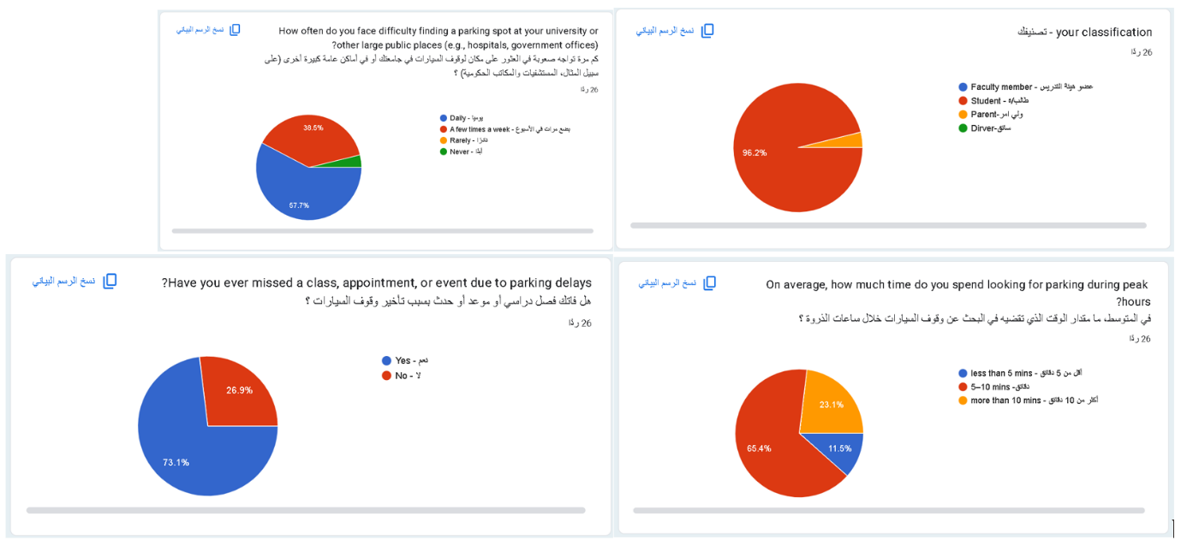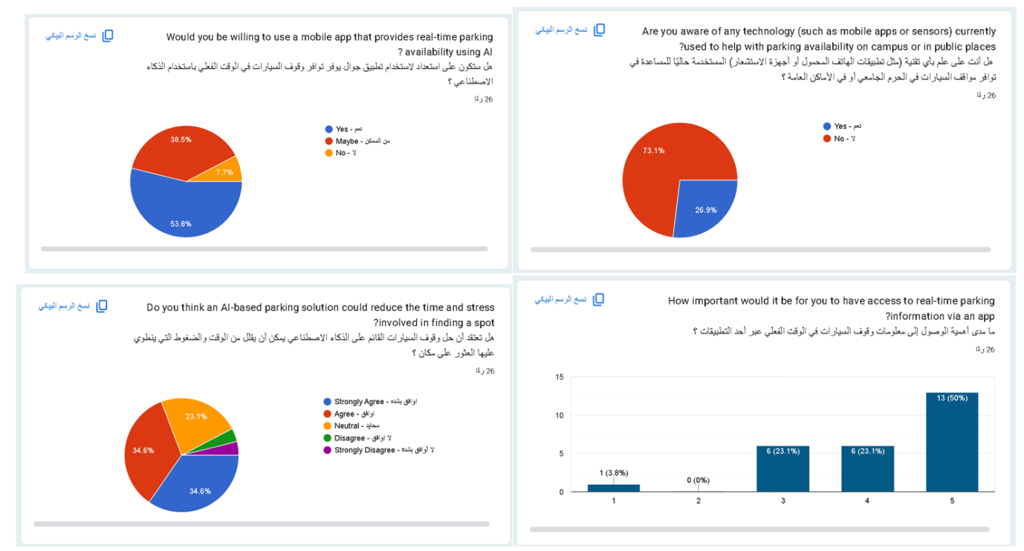
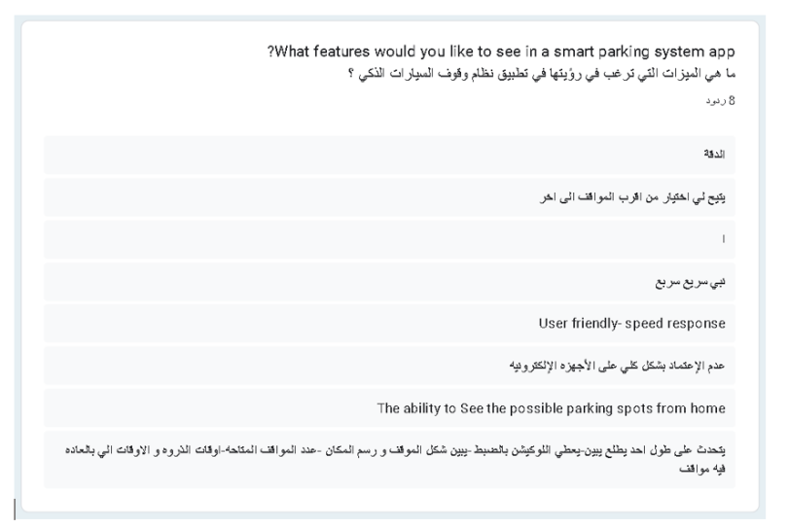
The target users of this project are diverse stakeholders—faculty members, students, parents and drivers—who all encounter considerable difficulty when attempting to secure parking at universities and other public venues. At present, users routinely experience uncertainty about space availability as they approach campus parking areas, often spending more than ten minutes searching for a vacancy. This prolonged search not only engenders anxiety and stress but also contributes to significant delays, causing many to miss classes, appointments or important meetings. Existing applications, where known, fail to alleviate these issues due to either limited functionality or lack of real-time data, and many users remain unaware of such tools altogether. Survey and interview feedback consistently underscores the demand for an intelligent, AI-driven solution capable of delivering up-to-the-minute information on parking availability, thereby minimizing time spent searching, reducing stress, and improving overall punctuality.

3. Solution Identification

Project Logbook 3.1: Selection and Justification of Solution

 | Project Logbook (3.1: Selection and Justification of Solution)  Alongside the primary challenges identified, we have developed the following top five innovative ideas to effectively address the parking issues:  - AI-Powered Camera System for Real-Time Parking Detection  - Interactive AI-Based Parking Map  - Predictive Model for Parking Availability (5–10 Minutes Ahead)  - Smart Arrival Time Recommendation App  - AI Voice Assistant for Parking Guidance

Discussion for each identified solution

- AI-Powered Camera System for Real-Time Parking Detection
Use machine learning with surveillance cameras to detect available parking spots and update availability in real-time.
- Interactive AI-Based Parking Map
A dynamic map that learns user behavior and traffic flow to suggest the best parking areas nearby based on real-time and historical data.
- Predictive Model for Parking Availability (5–10 Minutes Ahead)
A machine learning system that predicts how many parking spots will be available in the next few minutes, helping users decide whether to wait or look elsewhere.
- Smart Arrival Time Recommendation App
An application that analyzes traffic, historical occupancy data, and events to recommend the best times for users to arrive at their destination.
- AI Voice Assistant for Parking Guidance
A voice-based assistant integrated into a mobile app that guides users to available parking and provides alerts or suggestions while driving.

Project Logbook 3.2: Prioritizing Idea/Solution

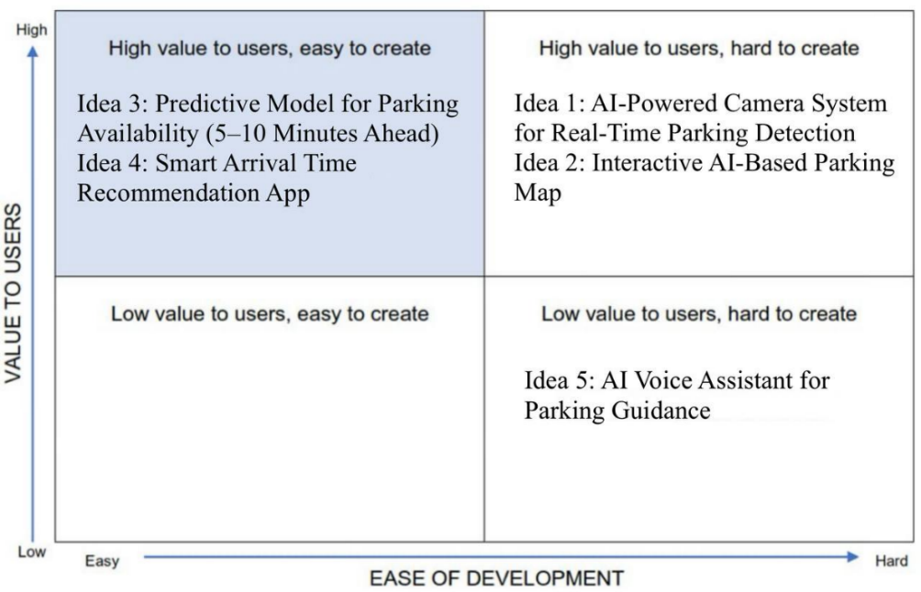

Project Logbook 3.3: Solution Description
- Describe and justify your selected solution.

 | Project Logbook (3.3: Solution Description)  Idea 3 – Predictive Model for Parking Availability (5–10 Minutes Ahead)

What is our solution?
Our solution is a predictive AI model that forecasts parking availability 5 to 10 minutes into the future. It provides users with real-time insights about where parking spaces are likely to be available soon, helping them make faster and smarter decisions before arriving.

How we will implement the solution:
We will implement this solution by using historical parking data, which will include information such as parking slot ID, day of the week, hour of the day, and previous usage patterns. We will select a regression model because predicting parking availability involves estimating a numerical outcome (whether a slot will be available or occupied), which depends on several continuous and categorical input features. Although the final prediction can be interpreted as a category (0 for available, 1 for occupied), it will be derived from patterns in numerical data, making regression a suitable and flexible choice.
We will train a Random Forest classifier with hyperparameter tuning via Grid Search to optimize prediction accuracy. The model will analyse temporal and spatial patterns to predict near-future parking availability. We plan to utilize Python along with popular libraries like pandas, scikit-learn, and imbalanced-learn to preprocess the data, handle class imbalance with SMOTE, and build a robust predictive system.

4. Solution Design

Project Logbook 4.1: System Flow
Activity Diagram Components:
- Start Node
- ● A small black circle.
- Represents the beginning of the activity flow.
- Activity
- ◼️ A rounded rectangle.
- Represents an action performed by the user or system, such as "User opens app".
- Decision Node
- 🔷 A diamond shape (rhombus).
- Represents a decision point where the flow branches based on a condition (e.g., Yes or No).
- Edges (Transitions)
- ➡️ Arrows connecting elements.
- Indicate the flow from one activity or decision to the next.
- End Node
- ◉ A black circle within a larger circle.
- Indicates the end of the process or workflow.

Activity Diagram Steps:
- Start Node: The beginning of the process when the user starts using the application.
- User opens Parking App: The user opens the parking application on his device.
- User enters destruction/area: The user enters his destination or the area in which he wishes to park.
- App sends request to AI engine: The application sends the request to the artificial intelligence engine to process the data.
- AI analyzes data and predicts availability: AI analyzes data and predicts availability of situations after 5–10 minutes based on machine learning models.
- App displays predicted availability: The application displays expected results about the availability of parking in the selected area.
- Decision: Users accept suggestion? The user decides whether to accept the suggestion made by the application.
- If Yes → Navigate to suggested area: If the user agrees, he starts navigating to the suggested area.
- If No → Try different time or area: If the user refuses, they are allowed to try another time or area by returning to the new destination entry.
- End Node: The process ends either after deciding and navigating or after searching for an alternative option.

System flow Diagram

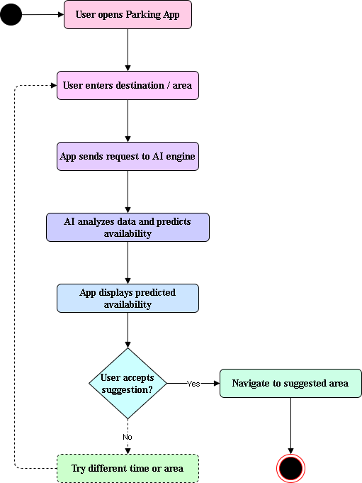
Figure 2. Activity Diagram

5. Data Requirements

Project Logbook 5.1: Data Description

Feature Name | Meaning | Use in Model
slot_id | The ID of the parking slot (like IR1, IR2, etc.) | It identifies each specific spot, which may have different usage patterns. For example, in Al-Madinah Haram, some slots near the women’s entrance are preferred by users. The model uses this to improve availability predictions.
field2 (Availability) | Indicates whether the slot is occupied (1) or available (0) | This is what the model learns to predict — whether a slot will be free or occupied in a future time.
day_of_week | Number indicating the day (1 = Monday, 7 = Sunday) | Helps the model understand weekly patterns, e.g., weekends might be more free or busy.
hour_of_day | The hour of the day (0 to 23) | Identifies rush hours and predicts availability based on time of day (e.g., more full at 8 AM).
prev_usage | A value indicating if the slot was recently used (e.g., 1 = yes, 0 = no) | Adds historical behavior to help the model better guess future usage. A slot recently used might stay occupied.

Project Logbook 5.2: Data Collection and Ethical issues
Data collection methods for predicting parking availability involve leveraging publicly available datasets from Kaggle, specifically the Suwesh (2023) IoT-based smart parking system dataset. Suwesh. (2023). IoT-based smart parking system dataset [Data set]. Kaggle. https://www.kaggle.com/datasets/suwesh/iot-based-smart-parking-system-dataset
The original dataset was subsequently modified to incorporate additional features for enhanced analysis:

The first is data anonymization, ensuring that no sensitive or personal information about users that could reveal their identity is present in the dataset. This ensures that the data complies with privacy laws. Data security measures were implemented to ensure that the data is stored and processed in secure environments, protecting it from unauthorized access or misuse. We also focused on bias mitigation, carefully addressing usage patterns or time periods. Additional preprocessing and feature engineering were applied to balance the dataset and reduce model bias.

6. Protype Development

Project Logbook 6.1: Tools used for Project Prototyping
- Python with libraries like pandas, scikit-learn, and matplotlib.
Why These Tools Were Chosen:
- Python: Easy-to-understand and widely used for AI projects.
- Pandas: For data cleaning and handling Excel sheets.
- Scikit-learn: To train and evaluate machine learning models like Random Forest.
- Excel: Used to organize the historical IoT data collected from parking slots.

Project Logbook 6.2: Results Discussion

Outcome | Explanation | How It Helps Solve the Problem
Availability Prediction | The model predicts whether a specific parking slot will be available or occupied at a given time. | Helps users plan ahead and avoid circling for empty spots.
Time-based Usage Analysis | Analyses patterns in parking usage based on day of the week and hour of day. | Allows campus managers to identify peak congestion times and make scheduling or policy changes.
Slot Utilization Tracking | Identifies which parking slots are used most or least often over time. | Assists in redesigning parking layouts or expanding underused areas.
Improved User Experience | Reduces uncertainty and stress related to parking decisions. | Students waste less time and arrive on time, improving academic performance and satisfaction.

Project Logbook 6.3: Testing Prototype
Scenario: Every Friday at 5 p.m., Mohammed arrives at the university for a group review session before exams. However, he often has difficulty finding a parking space, forcing him to be late or park far away.

Slot Code (IR11 → 2)
Description: A numeric identifier representing a specific parking space.
Usage: The model helps identify usage trends associated with each parking space.

Day of the Week (5 for Friday)
Description: A numeric value indicating the day.
Usage: The model detects patterns such as high demand on the first day of the week.

Hour of the Day (17 p.m.)
Description: The time the user wishes to park.
Usage: Critical for identifying peak and slack periods.

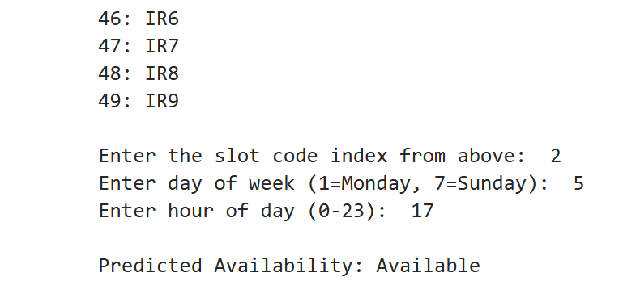

Project Logbook 6.4: Testing Feedback
- Prediction Accuracy: Generally good, but needs improvement for rare time slots.
- User Input: Users found it hard to map slot codes (e.g., IR11 → 2); suggest adding a dropdown.
- Prev_usage Limitations: Not always reliable—misses unexpected changes like holidays.
- Speed: Fast predictions, suitable for real-time use.
- Explainability: Users want to know why a prediction was made; add simple explanations.
- Visualization: Confusion matrix helped developers; users prefer simpler outputs

Project Logbook 6.5: Recommendations and Future Improvement

- Increase Data Size and Quality
Collect more data, including weather conditions, special events to improve model accuracy.
- Improve Input and Output Interface
Allow users to select slots directly and provide a more user-friendly input method.
- Integrate Real-Time Data
Connect to live sensor data for up-to-date availability and better predictions.
- Deploy as a Mobile/Web App
Make predictions easily accessible to users through a dedicated application.
- Provide Prediction Confidence
Show users how confident the system is in its prediction to support decision-making.

Project Logbook 6.6: Screen shot of Prototype
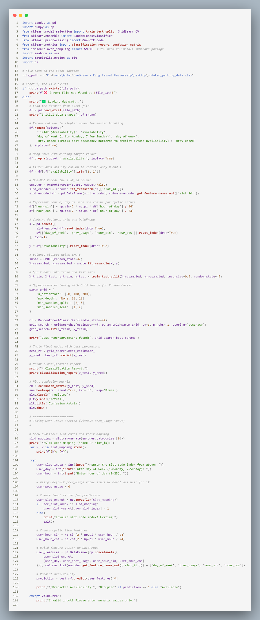

  - Model Training and Evaluation:
This shows the console output after training the Random Forest model with hyperparameter tuning using Grid Search. It displays the classification report and sample predictions on the test data. These results help evaluate how accurately the model can predict parking slot availability based on features like slot ID, day of the week, hour of day, and previous usage.

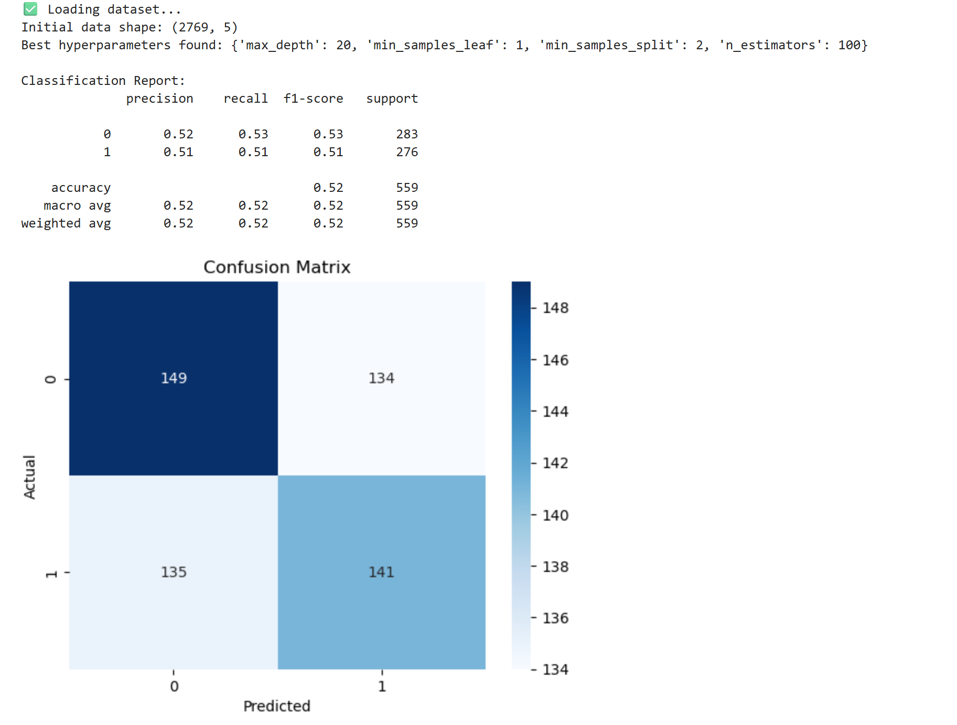

  - Confusion matrix:
A confusion matrix is used to evaluate the performance of a classification model by showing how many predictions were correct or incorrect. It breaks down results into four categories: true positives, true negatives, false positives, and false negatives. This helps calculate key metrics like accuracy, precision, recall, and F1-score. In a parking availability model, it reveals how well the system predicts whether a slot is occupied or available, helping identify if the model favors one class over another and guiding improvements to reduce critical errors like false availability predictions.


- Actual 0, Predicted 0 (TN): 149
- Actual 0, Predicted 1 (FP): 135
- Actual 1, Predicted 0 (FN): 134
- Actual 1, Predicted 1 (TP): 141

  - User Input and Prediction:
This shows a section of the script where the user inputs a specific slot, day, and hour. The system then predicts whether the slot will be available, helping the user plan their visit.
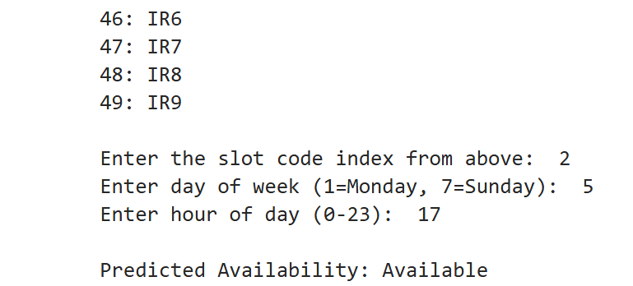

7. Student Reflection

Project Logbook 7.1: Learning Reflection

At the beginning of the project, we struggled to find free and available research that supports the idea of the project. During the interview, I faced a challenge because the interviewee tended to express emotions and focus on the consequences rather than stating the problem directly. This made it hard to list the challenges clearly. However, this experience helped me improve my ability to listen carefully, analyse spoken information, and extract the actual problem. It trained me to rephrase and define the issue in a clearer way, which is a valuable skill in understanding and solving real-life problems.
Another challenge I faced was finding the right dataset. Most of the available datasets were very basic and lacked the specific features I needed for my project. To overcome this, I used Python to load and process the data, adding extra features that better supported the predictive model. This taught me how to enhance and adapt datasets to fit the requirements of my project more effectively.

References
- Kaleem, K. S., Raju, A. S., Giweli, N., Dawoud, A., Prasad, P. W. C., & Kashef, M. A. (2021). IoT regression techniques in smart parking systems: Survey. In 2021 6th International Conference on Innovative Technology in Intelligent System and Industrial Applications (CITISIA) (pp. 1–10). IEEE. https://doi.org/10.1109/CITISIA53721.2021.9719884
- Gupta, S., Tiwari, A., & Jindal, A. (2023). Condition Monitoring using Machine Learning: A Review of Theory and Applications. Expert Systems with Applications, 119738. https://doi.org/10.1016/j.eswa.2023.119738

